DAY 19
Task 1:
Wrapper classes are classes that wrap primitive data types into objects.
Task 2:
Autoboxing and Unboxing are automatic conversions between primitive data types and their corresponding wrapper classes.
Task 3:
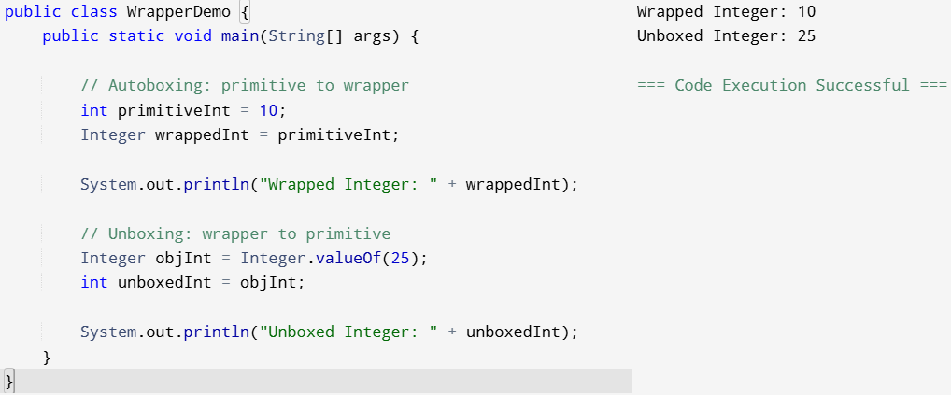
Task 4:
Wrapper classes are used whenever an object is required instead of a primitive data type.
Task 5:
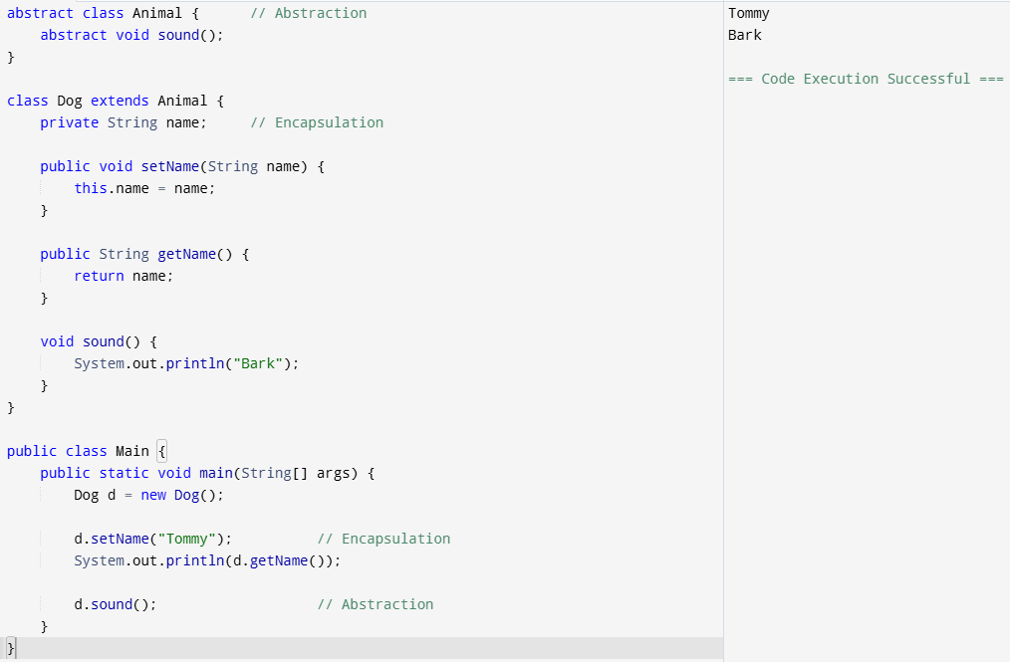
Task 6:
The Executor Framework was introduced in Java 5 under the java.util.concurrent package to simplify the creation and management of threads.
Task 7:
Executor is an interface used to execute tasks.
ExecutorService is an interface that extends Executor and provides thread pool management, task submission, and shutdown operations.
Executors is a utility class that creates ExecutorService objects such as fixed, cached, single, and scheduled thread pools.
Task 8:
We use Callable with Future when a task needs to run in a separate thread and return a result back to the main thread.
Task 9:
First, we create an ExecutorService using the Executors factory class. Then we submit tasks using submit(), which returns a Future object. The Future is used to retrieve the result using get(), and finally we call shutdown() to release the thread pool resources.
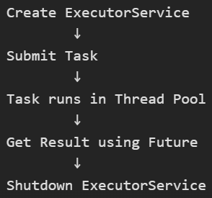
Task 10:
Character Input/Output using FileReader & FileWriter

Concept Used
- FileWriter → Writes characters to a file.
- FileReader → Reads characters from a file.

Buffered I/O (BufferedReader & BufferedWriter)
- BufferedWriter writes data using a buffer, making it faster.
- BufferedReader reads data line by line using readLine().
Task 11:
Object is the root (superclass) of all classes in Java.
Every class in Java directly or indirectly inherits from the Object class.
Why do we use the Object Class?
- Since all classes inherit from Object, they automatically get common methods.
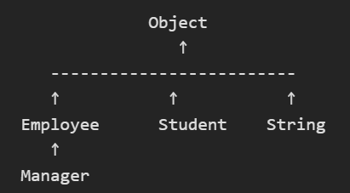
Task 12:
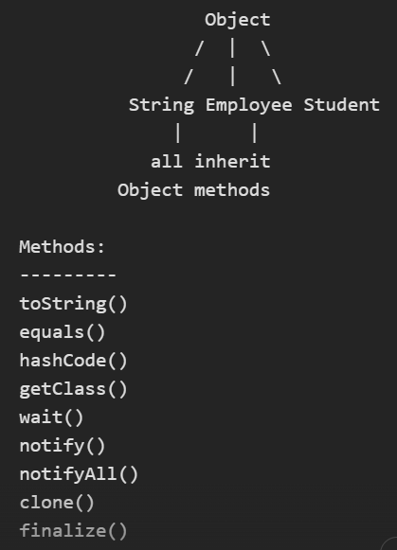
Task 13:
Generics allow you to write a class, method, or interface that can work with different data types while maintaining type safety.
Instead of writing separate code for String, Integer, etc., you can use a type parameter like <T>.
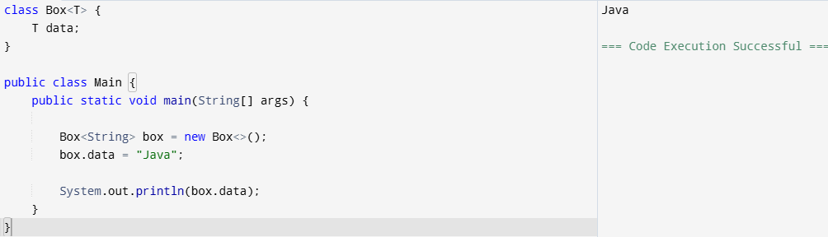

--------------------------------------------------------------------------------------------------------------
JAVA 8 Features
Task 1:
Lambda expressions were introduced to support functional programming and reduce boilerplate code.
Benefits:
- Enable passing behavior as a parameter.
- Simplify the implementation of functional interfaces.
- Improve readability and maintainability.
- Work seamlessly with the Stream API for data processing.
Task 2:
A functional interface is an interface that contains exactly one abstract method. It can have default and static methods.
- java.util.function.Predicate<T>
- Predicate<Integer> isEven = n -> n % 2 == 0;

- java.util.function.Consumer<T>
- Consumer<String> printer = s -> System.out.println(s)

Task 3:
Collections | Streams
Store data in memory | Process data from a source
Mainly used for data storage | Mainly used for data transformation and computation
Can be traversed multiple times | Can be traversed only once
Supports external iteration | Supports internal iteration
Elements can be modified | Stream operations generally do not modify the source

Task 4:
Optional<T> helps avoid NullPointerException by explicitly representing the presence or absence of a value.
Advantages:
- Reduces null checks.
- Makes APIs more expressive.
- Encourages safer coding practices.
Task 5:
Default methods were introduced to allow adding new methods to existing interfaces without breaking existing implementations.
Benefits:
- Backward compatibility.
- Easier API evolution.
- Enables interfaces to contain behavior along with contracts.
A major example is the addition of methods such as forEach() and stream() to existing collection interfaces.
Task 6:
Method references provide a shorthand syntax for lambda expressions that simply call an existing method.
Task 7:
The Java 8 Date-Time API (java.time) was introduced to address the shortcomings of java.util.Date and Calendar.
Improvements:
- Immutable and thread-safe classes.
- Clear separation of date, time, and datetime.
- Better timezone handling.
- More readable API.
- Easier date calculations.
Task 8:
Java 8 introduced the java.util.Base64 package, eliminating the need for third-party libraries.
Benefits:
- Built-in support.
- Easy-to-use API.
- Supports Basic, URL, and MIME encoding formats.
Task 9:
Static methods in interfaces are useful when utility methods are closely related to the interface.
Real-world use cases:
- Validation helpers (isValidAmount()).
- Factory methods.
- Utility operations related to the interface contract.
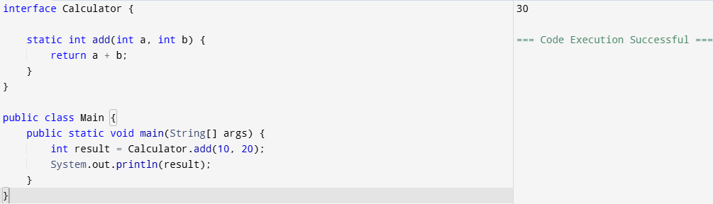
Task 19:
Q1 –
A code smell is an indication that the code may have poor design, structure, or maintainability. It does not necessarily cause the application to fail but suggests that future problems may arise.
Code Smell
- Indicates poor design or bad coding practices.
- Code still works correctly.
- Makes maintenance harder.
Bug/Error
- Causes incorrect behaviour or application failure.
- Directly affects functionality.
Q2 –
Code smells are often symptoms of underlying design issues.
For example:
- A Long Method may indicate poor separation of responsibilities.
- A Large Class may violate the Single Responsibility Principle.
- Duplicated Code may indicate missing abstraction or reuse.
Q3 –
Maintainability
Code becomes difficult to modify and debug.
Developers spend more time understanding the code before making changes.
Scalability
Adding new features becomes difficult because tightly coupled or poorly designed code is harder to extend.
Readability
Complex, duplicated, or oversized code is difficult for new developers to understand.
Effects:
- Increased development effort
- Higher maintenance costs
- Greater risk of introducing bugs
- Reduced productivity
Q4 –
Long Method
A method that contains too many lines of code and performs multiple tasks.
Problems
- Difficult to read
- Difficult to test
- Difficult to reuse
Solution
- Extract smaller methods.
Large Class
A class that contains too many fields, methods, and responsibilities.
Problems
- Violates Single Responsibility Principle
- Hard to maintain
- Hard to understand
Solution
- Split the class into smaller focused classes.
Q5 –
It increases maintenance effort, makes bug fixing difficult, and can lead to inconsistent behaviour.
1. Difficult Maintenance
2. Bug Fixing Becomes Hard
3. Increased Complexity
4. Risk of Inconsistency

